TNE20003 – Internet and Cybersecurity for Engineering Applications

Portfolio Task – Lab 3 Distinction Task

Aims:
- To practice subnetting
- To understand how arp works
- To investigate how MAC addresses are used and how the CAM table in a switch is populated.

Preparation:
  - View “Network Devices - Routers and Switches”
  - Lab 2 D Task

Due Date:
- Task1 must be completed before the lab and uploaded to Canvas. Your demonstrator will check the answers to the questions and your working out for task 1 and may ask questions during the lab session. Task 2 will be assessed via an online quiz. You must score the required minimum to pass the test. You will be allowed a number of attempts to pass the test at that grade level. You are encouraged to complete the test during the lab but if you do not, you must complete it before your next lab class.

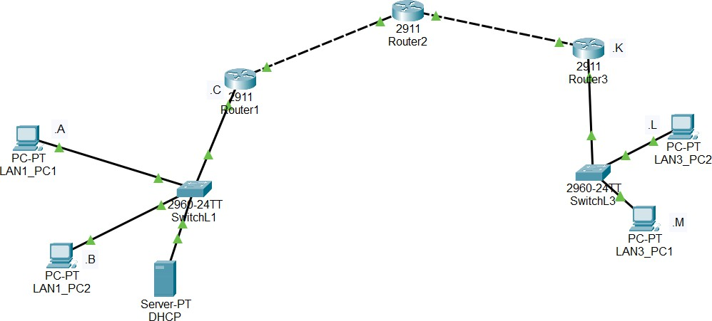
Task 1.
150.100.120.0/19
Practice Subnetting
In this task, you will
- Subnet the given network (n/w) in the diagram below and allocate a subnet address to each relevant segment.

Figure 1

150.100.120.0/19
What is the subnetwork address of the IP given above????
New subnet mask => /21
How many n/ws do we need to build this n/w? 4
How many bits need to be borrowed? 2
What do the dotted lines connecting 2 routers mean?
Copper cross over cabling

Task 2.
Build the network provided in task 1 with Cisco Packet Tracer and observe the building of ARP tables in the PCs and CAM table in the switch

Implement the network shown in figure 1 above.
The bottom left hand corner of the Packet tracer screen displays the icons that represent device categories or groups, such as Routers, Switches, or End Devices.
Moving the cursor over the device categories will show the name of the category in the box. To select a device, first select the device category. When the device category is selected, the options within that category appear in the box next to the category listings. Select the device option that is required.
  - Select End Devices from the options in the bottom left-hand corner. Drag and drop 4 PCs and 1 Server onto your design area.
  - Select Switch from the options in the bottom left-hand corner. Add 2 2960 switches to your prototype network by dragging them onto your design area.
  - Select Router from the options in the bottom left-hand corner. Add 4 2911 routers to your prototype network by dragging them onto your design area
  - Double click on each of the devices and name them as per the network diagram in figure 1.
  - Select Connections from the bottom left-hand corner. Choose a copper straight-through cable type. Click the first PC (PC1) and assign the cable to the FastEthernet0 connector. Click the switch (LS1) and select FastEthernet0/1 to connect to PC1.
  - Select Connections from the bottom left-hand corner. Choose a copper straight-through cable type. Click the second PC (PC2) and assign the cable to the FastEthernet0 connector. Click LS1 and select FastEthernet0/2 to connect to PC2.
  - Select Connections from the bottom left-hand corner. Choose a copper straight-through cable type. Click the third PC (PC3) and assign the cable to the FastEthernet0 connector. Click LS1 and select FastEthernet0/3 to connect to PC3.
  - Select Connections from the bottom left-hand corner. Choose a copper straight-through cable type. Click the switch (LS1) and select FastEthernet0/4 to connect to GigabitEthernet0/0 of Rtr1.
  - Repeat these steps for all of the other devices until they are all connected as per the n/w diagram in figure 1. Note when connecting 2 routers together you need to use a cross-over cable because they are like devices, ie both are DTEs. Or you can use a serial cable.

There should be green dots at both ends of each cable connection after the network has converged. If not, double check the cable type selected. Note with the routers in particular, you may need to turn that interface on by clicking the “on” button under the interface tab or by issuing the command “no shut” on the interface in the CLI mode.
See below:
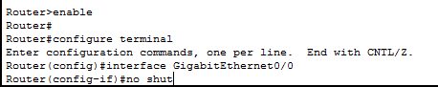

Configure Host names and IP Addresses on the PCs, the Server, the switches and the routers as per the n/w diagram in figure 1 above.
- On each PC observe the current status of the ARP table by issuing the following command and note what is displayed.
  - Click on the PC and choose “desktop” and then click on the “command prompt”
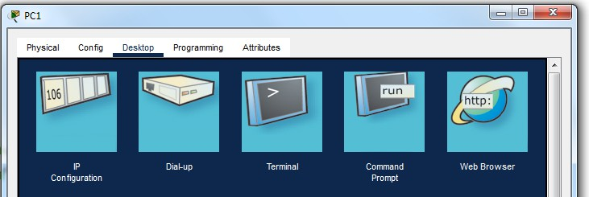
  - When the “command prompt” window appears type “arp -a”
  - Record what is displayed.
No entries found

On the switch LS1 issue the following commands to see what is stored in the CAM table
  - Choose the “CLI” mode
  - Click enter until you see the following prompt: Switch>

  - Type “enable”
  - Type “show arp” what do you see? See pic below for guide
  - You can investigate the CAM table of the switch by typing “show mac address-table". what do you see?
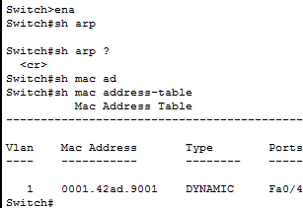

  - Whose MAC address could this be?
Default gateway port on router1
  - Before you leave the switch type the following commands to make sure it stays in the privileged mode of operation. See pic below for commands and steps.
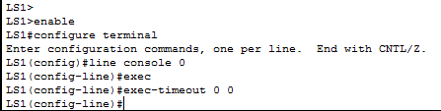

If want to observe the flow of data in PT between PC1 and PC2 follow the commands below or jump to step 6.
  - Switch to Simulation Mode in the bottom right-hand corner.

  - Click Edit Filter in the Edit List Filter area. In the event list filter, only select ARP and ICMP filters under IPv4 tab, deselect all other filters in the three tabs IPV4, IPV6 and Misc.
  - Select a Simple PDU by clicking the closed envelope in the upper toolbar.
With the envelop icon, click PC2 to establish the source. Click PC1 to establish the destination.

Let’s investigate what happens to the ARP tables of the PC and the CAM table of LS1 when we issue some more pings.
  - Click on PC2 and from the Desktop link choose the Command Prompt and type the following command when you see the prompt C:\>“ping (put the IP address of PC1 here)” and you should see something similar to the pic below
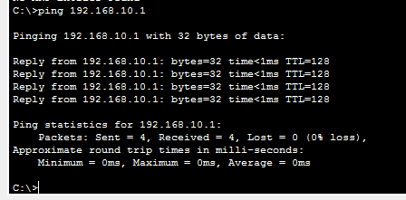
  - Repeat steps 3 and 4 above to see if any of the tables have changed.
  - What did you observe? Did anything change in the CAM table of LS1. Explain it in your own words.
CAM table has entries from incoming ports of PC1 and PC2 respectively.
  - What happens to the CAM table in LS1 if you don’t do anything for a period of time (more that 5 min)?
CAM table will be refreshed and emptied.

Using the IP addresses you have configured previously, from PC2 ping all of the other PCs including the server.
  - Click on PC2 and from the Desktop Command Prompt type “ping (put the IP address of PC3 here)”. Look at the CAM table of LS1, has there been any changes.

  - Click on PC2 and from the Desktop Command Prompt type “ping (put the IP address of R1 interface connected to the switch)”. Was the ping successful? Explain why or why not. Look at the CAM table of LS1, has there been any changes.
  - Click on PC2 and from the Desktop Command Prompt type “ping (put the IP address of PC4 here)” Was the ping successful? Explain why or why not. Look at the CAM table of LS1, has there been any changes.
  - Click on LAN_PC2 and from the Desktop Command Prompt type “ping (put the IP address of the Server here)” Was the ping successful? Explain why or why not. Look at the CAM table of LS1, has there been any changes.
  - What did you observe? Explain it in your own words.
Initial pings will be unsuccessful due to empty arp entry for the server. However eventually results in successful pings

We need to facilitate end-to-end communication.
  - Using your prior knowledge gained from lab 2 D enter a default gateway into each of the PCs and the Server and add the relevant static routes to ensure end-to-end connectivity.
  - On LAN1_PC1 issue the command arp -a. What do you see? Make note of the mappings that exist.
  - Ping from LAN1_PC1 to Router 2. The ping should be successful. If not investigate and rectify the problem.
  - On LAN1_PC1 issue the command arp -a. What do you see? Has the MAC address of Router1 been added to your ARP table?
  - Ping from LAN1_PC1 to Router 3. The ping should be successful. If not investigate and rectify the problem.
  - On LAN1_PC1 issue the command arp -a. What do you see? Has the MAC address of Router2 been added to your ARP table?
  - Ping from LAN1_PC1 to LAN3_PC1. The ping should be successful. If not investigate and rectify the problem.
  - On LAN1_PC1 issue the command arp -a. What do you see? Has the MAC address of LAN3_PC1 been added to your ARP table?
  - What conclusion can you draw about the ARP process across different networks?
Only the default gateway interface IP and MAC will be in the arp table, because communication outside the local network must be through the router.
~~~~~ End of Lab ~~~~~

